SIMATS ENGINEERING
DEPARTMENT OF COMPUTER SCIENCE & ENGINEERING

COURSE NAME: Computer Vision with OpenCV COURSE CODE: DSA02
COURSE OUTCOME COVERED: CO2: Apply image processing and feature extraction techniques, including edge detection, motion estimation, and optical flow, for analyzing images.. (BL3)
ASSESSMENT TOOL 3 (CLASS TEST) | Weightage: 20% | Total Marks: 20
Code of Conduct:
I J.Vishnu Vardhan (192324297) (Name / Reg No) certify that this submission is my original work and that I have adhered to the guidelines specified for this assessment. I understand that any violation of academic integrity rules will result in disciplinary action.
Signature of the student: J.Vishnu Vardhan

RUBRICS FOR CALCULATION

Explanation
Demonstrates thorough, Good understanding with Basic understanding with Poor understanding; accurate understanding minor gaps some misconceptions major
of concepts misconceptions
25%
Understanding of Concepts
Marks
Level 1
(Beginning)
Weightage Level 4 (Exemplary) Level 3 (Proficient) Level 2 (Developing)
Criteria
25%
Detailed, well-explained
Clear explanation with Limited explanation;
Poor or unclear

answers with relevant adequate details lacks depth explanation examples

Organization 15%
Application
20%
Effectively applies
concepts with strong analytical ability
Applies concepts with minor errors
Limited application with No application or
weak analysis
incorrect analysis
Well-structured answers
Organized with minor Basic structure, lacks Poor organization,

with logical flow and issues in flow clarity incoherent answers coherence

Clarity 5%
Accuracy
10%
Completely accurate and Mostly accurate with covers all required points minor omissions
Partially correct with missing points
Incorrect answers with major gaps
Clear, neat, professional Understandable with Limited clarity, Poorly written, presentation minor issues readability issues difficult to
understand

Question 1: Image Preprocessing and Feature Extraction (10 Marks)
SCENARIO: Drone Aerial Farmland Pest Damage Identification
A drone is used to capture aerial images of a farmland to identify pest-affected crop regions. Due to sensor limitations, wind movement, and changing sunlight, the captured images contain noise, shadows, and uneven illumination. Pest-affected areas usually show visible texture and color variations compared to healthy crop regions.

Preprocessing Pipeline — Comprehensive Multi-Stage Architecture (4 Marks)
To prepare raw aerial farmland drone images for automated pest detection, a multi-stage sequential image processing pipeline must be implemented. Raw images suffer from atmospheric turbulence, wind-induced motion blur, sensor thermal noise, non-uniform solar illumination, and cloud cast shadows. Below is the complete mathematical and algorithmic formulation of the preprocessing pipeline:

Stage 1: Noise Reduction & Edge-Preserving Filtering (Bilateral Filter / Gaussian Smoothing):
Sensor thermal noise and small motion blur are smoothed using an Edge-Preserving Bilateral Filter. Standard Gaussian filters compute spatial distance weighting, which blurs leaf margins. The Bilateral Filter combines spatial domain Gaussian weighting with intensity range Gaussian weighting:
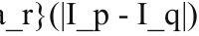 BF[I]_p = (1 / W_p) * Sum_{q in S} I_q * g_{sigma_s}(||p - q||) * g_{sigma_r}(|I_p - I_q|) where g_{sigma_s} is the spatial Gaussian kernel controlling spatial neighborhood blur, g_{sigma_r} is the range Gaussian kernel controlling edge thresholding, and W_p is the normalization factor.
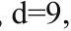 OpenCV Implementation: cv2.bilateralFilter(src, d=9, sigmaColor=75, sigmaSpace=75) Engineering Justification: This stage eliminates high-frequency sensor noise and camera jitter while maintaining sharp boundaries between healthy leaf tissue and pest lesions.

Stage 2: Illumination Correction & Cloud Shadow Removal (Homomorphic Filtering / Top-Hat Morphological Transform):
Solar angle changes and cloud shadows introduce non-uniform spatial illumination gradients. Homomorphic filtering
models an image as the product of illumination i(x,y) (low 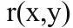 spatial frequency) and reflectance r(x,y) (high spatial frequency):

ln(r(x,y))
f(x,y) = i(x,y) * r(x,y) => ln(f(x,y)) = ln(i(x,y)) +

Taking the 2D Fast Fourier Transform (FFT): F(u,v) = F(ln(i)) + F(ln(r)). Applying a

Butterworth/Gaussian high-pass transfer function H(u,v) suppresses low-frequency illumination i(x,y) while boosting high- frequency reflectance r(x,y): H(u,v) = (gamma_H - gamma_L) * [1 - exp(-c * (D^2(u,v) / D_0^2))] + gamma_L
OpenCV Alternative: Top-Hat Morphological Transform: TopHat(I) = I - (I o SE), using a large structuring element (e.g., 31x31 disk) to subtract uneven background lighting.
Engineering Justification: Ensures that subsequent thresholding and feature extraction algorithms operate on uniform background illumination across the entire 2D aerial field view.

Stage 3: Local Contrast Enhancement via CLAHE (Contrast Limited Adaptive Histogram Equalization):
Global histogram equalization amplifies background noise in uniform crop areas. CLAHE partitions the image into
small contextual 8x8 tiles. For each tile, local intensity histogram is computed and clipped at a predefined limit (e.g.,

clipLimit=3.0) to prevent over-saturation. The clipped pixels are redistributed uniformly across the histogram before bilinear interpolation.
Color Space Processing: The image is transformed from RGB to CIE LAB color space. CLAHE is applied exclusively to the L* (Luminance) channel to preserve natural leaf color fidelity: OpenCV Implementation: clahe = cv2.createCLAHE(clipLimit=3.0, tileGridSize=(8,8)); L_enhanced = clahe.apply(L_channel)
Engineering Justification: Enhances subtle local boundary contrast between discolored pest-nibbled leaf patches and healthy green foliage without distorting color channels.

Stage 4: Dynamic Range Min-Max Intensity Normalization:
To standardize pixel intensity scaling across drone flights taken at different times of day: I_norm(x,y) = [ (I(x,y) - I_min) / (I_max - I_min) ] * 255
OpenCV Implementation: cv2.normalize(src, dst, alpha=0, beta=255, norm_type=cv2.NORM_MINMAX) Engineering Justification: Converts dynamic range into a unified [0, 255] float/uint8 scale, enabling stable classification thresholds.
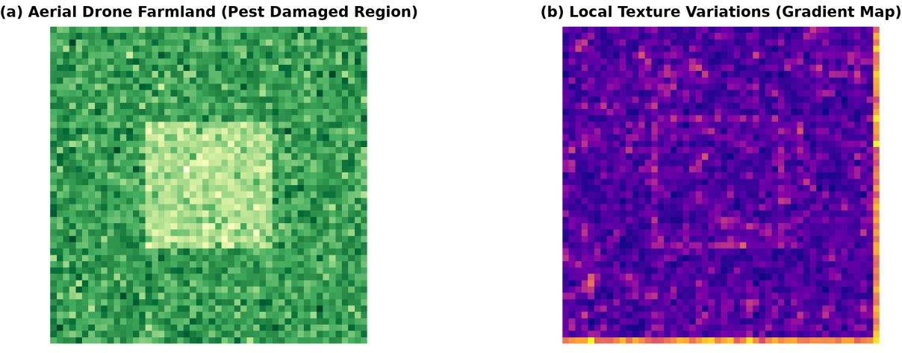
Figure 9: (a) Aerial Drone Farmland with Pest-Damaged Patch and (b) Local Gradient Texture Map.

Feature Extraction Selection & Justification (3 Marks)
Pest infestations manifest as both structural texture alterations (holes, leaf skeletonization, necrotic spots) and color variations (chlorosis, yellowing, browning). Therefore, a hybrid Feature Extraction Descriptor combining Local Binary Patterns (LBP) for micro-texture and Excess Green Index (ExG) for vegetation color is chosen:
- 1. Local Binary Patterns (LBP) for Texture Analysis: LBP is an exceptionally robust micro-texture 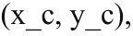 operator. For each pixel (x_c, y_c), LBP compares its intensity g_c against P circular spatial neighbors g_p at radius R:
LBP_{P,R}(x_c, y_c) = Sum_{p=0}^{P-1} s(g_p - g_c) * 2^p where threshold function s(x) = 1 if x >= 0 else 0.
Texture Discrimination Rationale: Healthy crop leaves exhibit smooth, highly uniform LBP codes. Pest damage (caterpillar holes, mite webbing, leaf miner trails) introduces high-frequency random edges and rough spatial discontinuities, altering local LBP histogram distributions.
- 2. Excess Green Vegetation Index (ExG) for Color Feature Extraction: RGB channels are normalized to

remove | overall |  | lighting | intensity dependencies:
r = | R / (R + G + B), | g | = G / (R + | G + B), b = B / (R + G + B)
ExG = 2*g - r - b
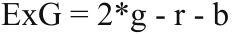
Color Discrimination Rationale: Healthy vegetation yields high positive ExG values (> 0.2). Pest-affected damaged crops exhibiting yellowing or browning drop significantly in ExG index. Combining LBP texture histograms with ExG mean/variance vectors produces a highly discriminative feature representation.

Handling Rotation and Scale Variations in Drone Imagery (3 Marks)
Impact of Drone Flight Dynamics:
- Scale Variations: Drones flying at varying altitudes (e.g., 30m vs 100m) change the pixel resolution of individual leaves. A fixed 3x3 filter will capture micro-texture at 30m but macro-field structures at 100m. Rotation Variations: Drone yaw angle adjustments, wind-induced camera pitch/roll, and flight path orientation changes rotate the captured farmland scenes arbitrarily.
Mitigation Methods for Scale and Rotation Invariance:
- 1. Rotation-Invariant Uniform LBP (LBP_{P,R}^{riu2}): Standard LBP is sensitive to rotation. Rotation invariance is achieved by performing bitwise circular right shifts on the binary pattern to find its minimum decimal value. Furthermore, uniform patterns (having at most two 0-to-1 or 1-to-0 transitions) are grouped into dedicated bins:

LBP_{P,R}^{riu2} = Sum_{p=0}^{P-1} s(g_p - g_c) if U(LBP_{P,R}) <= 2 else P + 1
where U(LBP) =
|s(g_{P-1}-g_c) - s(g_0-g_c)| + Sum_{p=1}^{P-1} |s(g_p-g_c) - s(g_{p-1}-g_c)|. This guarantees identical texture descriptor output regardless of drone camera orientation.
2. Scale-Space Pyramid & Scale-Invariant Feature Transform (SIFT): To handle scale variations, images are constructed into a Gaussian Scale Space Pyramid L(x,y,sigma) = G(x,y,sigma) * I(x,y). Keypoints are
detected at local extrema of Difference-of-Gaussians (DoG) octaves: D(x,y,sigma) = L(x,y,k*sigma) - L(x,y,sigma). Dominant keypoint orientation is assigned from local gradient direction histograms,
SCENARIO:
Autonomous
Vehicle
Stereo
Vision
&
Motion
Tracking
A self-driving car is equipped with stereo cameras to navigate through a busy street. The system must estimate the distance of nearby vehicles and pedestrians in real time. It should also track moving objects
accurately to avoid collisions, especially when pedestrians or vehicles change speed suddenly.
rendering feature vectors fully scale and rotation invariant.
Question 2: Stereo Vision and Motion Estimation (10 Marks)

Stereo Disparity and Depth Estimation — Mathematical Derivation (4 Marks)
Stereo vision mimics human binocular vision by capturing two horizontal views of a scene using a calibrated left camera C_L and right camera C_R separated by a baseline distance B. The optical axes of both cameras are parallel, having focal length f.
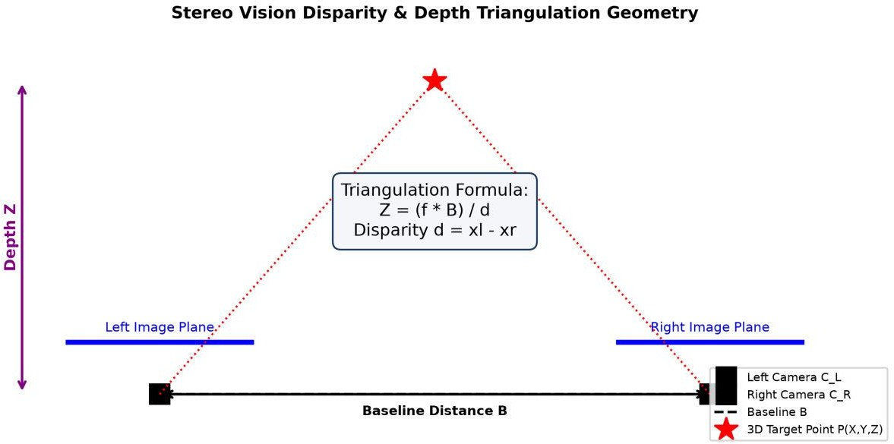
Figure 10: Stereo Vision Disparity & Depth Triangulation Geometry.
Mathematical Derivation of Triangulation:

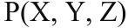
Let P(X, Y, Z) be a 3D point in the physical world. Its projection on the left image plane is x_l and on the right image plane is x_r:
x_l = f * (X / Z), x_r = f * ((X - B) / Z) Subtracting x_r from x_l yields Disparity d:
d = x_l - x_r = f * (X / Z) - f * ((X - B) / Z) = (f * B)
/ Z
Rearranging for Depth Z:

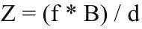 Z = (f * B) / d Analysis of Disparity Behavior:
- Nearby Objects (Z is small): Produce a LARGE disparity value d. Small changes in depth Z create large pixel shifts between left and right images, resulting in high depth precision and accuracy.
- Distant Objects (Z is large): Produce a VERY SMALL disparity value d (approaching 0). Depth error grows
quadratically with distance: |dZ / dd| = (f * B) / d^2 = Z^2 / (f * B). Hence, distant object measurements exhibit higher depth quantization uncertainty.
Algorithmic Disparity Computation:
OpenCV computes dense disparity maps using Semi-Global Block Matching (SGBM), which minimizes an energy function E(D) over 8 path directions:
E(D) = Sum_p C(p, d_p) + Sum_{q in N_p} P_1 * I(|d_p - d_q| = 1) + Sum_{q in N_p} P_2 * I(|d_p - d_q| > 1)
where C(p,d_p) is matching cost (Birchfield-Tomasi), P_1 is penalty for small disparity changes, and P_2 is penalty for sharp depth discontinuities.

Optical Flow for Motion Tracking (3 Marks)
When a pedestrian or vehicle moves between consecutive video frames, Optical Flow computes the 2D 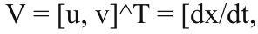 instantaneous velocity vector field V = [u, v]^T = [dx/dt, dy/dt]^T for every pixel.
Mathematical Formulation — Brightness Constancy Constraint Equation (BCCE):

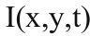
Assuming pixel intensity I(x,y,t) remains constant along the motion trajectory over time interval dt:
I(x, y, t) = I(x + dx, y + dy, t + dt) Applying 1st-order Taylor Series Expansion:
I(x + dx, y + dy, t + dt) = I(x,y,t) + (dI/dx)*dx + (dI/dy)*dy + (dI/dt)*dt + H.O.T.
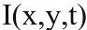
Subtracting I(x,y,t) and dividing by dt yields the fundamental Optical Flow Constraint Equation: I_x * u + I_y * v + I_t = 0 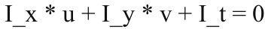 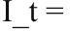 where I_x = dI/dx, I_y = dI/dy are spatial image gradients, and I_t = dI/dt is temporal derivative.
Pyramidal Lucas-Kanade for Large Sudden Movements:
- Multi-Scale Pyramids: Standard Lucas-Kanade fails during sudden pedestrian accelerations or turns because large displacements (> 2-3 pixels) violate Taylor series linearity. Pyramidal LK builds a Gaussian pyramid (L 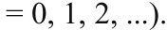
= 0, 1, 2, ...). Motion is estimated first at coarse scale L, upsampled, and refined locally at finer scales. Kalman Filter

Trajectory Forecasting: The optical flow velocity vectors [u, v]^T update a Kalman Filter
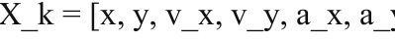
motion model state vector X_k = [x, y, v_x, v_y, a_x, a_y]^T. The Kalman filter predicts object position in 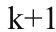frame k+1 using dynamic motion equations, enabling real-time collision avoidance even during abrupt turns or sudden braking.

Errors and Mitigation Techniques in Autonomous Driving (3 Marks)
Stereo depth estimation and optical flow tracking face severe real-world operational challenges. Below is a structured analysis of failure modes and mitigation strategies:
Failure Modes & Mitigation Matrix:
- 1. Camera Misalignment & Vehicle Vibration: Mechanical road shocks shift camera alignment, breaking epipolar geometry assumptions. Mitigation: Continuous online stereo self-calibration using 8-point fundamental matrix estimation (F) and epipolar rectification (cv2.stereoRectify).

2. Textureless Surfaces (Smooth Walls, Road Asphalt, Uniform Vehicles): Spatial gradients are zero (I_x 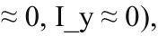≈ 0, I_y ≈ 0), causing singular structure tensor det(A^T A) ≈ 0. Mitigation: Sensor Fusion combining stereo cameras with LiDAR point clouds, and Deep Learning Stereo Matching (RAFT-Stereo / StereoNet). 3. Inter-Object Occlusion (Pedestrian crossing behind parked vehicles): Disparity cannot be computed for occluded pixels present in left view but hidden in right view. Mitigation: Left-Right Consistency Check
|d_L(p) - d_R(p - d_L(p))| <= 1. Unmatched occluded pixels are filled using spatial background interpolation. DeepSORT tracking with Re-ID feature embeddings maintains identity across occlusions.
- 4. Rapid Sudden Displacement & Fast Vehicle Speeds: Violates 1st-order small motion assumption.
Mitigation: High Frame Rate Cameras (120+ FPS) combined with Pyramidal Coarse-to-Fine Lucas-Kanade optical flow.
- 5. Outdoor Glare, Shadows, and Dynamic Lighting Shifts: Violates Brightness Constancy assumption 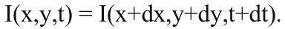 I(x,y,t) = I(x+dx,y+dy,t+dt). Mitigation: Gradient-based optical flow (tracking dI/dx rather than raw intensity I) and Census Transform cost functions.

